Cloud Attack Lab Report – IAM Privilege Escalation Using CloudGoat

This report documents the execution of a cloud attack simulation using CloudGoat, AWS CLI, and Pacu. The objective of the lab was to enumerate cloud assets, identify IAM misconfigurations, perform privilege escalation, and analyze the impact of insecure IAM instance profile permissions in AWS.

1. Objectives
Enumerate AWS IAM and EC2 resources.
Identify IAM misconfigurations.
Exploit EC2 instance-profile attachment permissions.
Demonstrate privilege escalation through IAM role abuse.
Clean up deployed cloud infrastructure after testing.

2. Tools Used
CloudGoat
AWS CLI
Pacu
Terraform
Kali Linux

3. Methodology and Execution

1: Pacu Framework Initialization
Pacu was initialized on the Kali Linux virtual machine to begin AWS privilege escalation assessment. The framework provides modules for IAM enumeration, permission analysis, and exploitation of AWS misconfigurations.

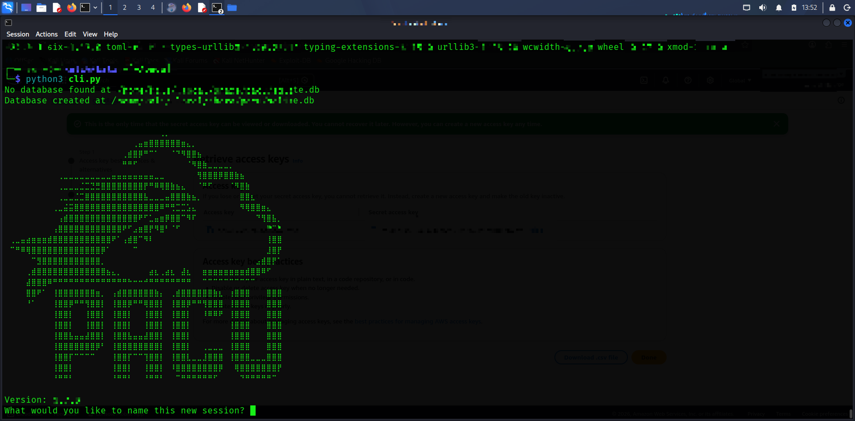

2: Enumeration of Limited IAM Permissions
Initial enumeration confirmed that the low-privileged user had restricted permissions. Access denial responses demonstrated the principle of least privilege while also indicating the need for privilege escalation.
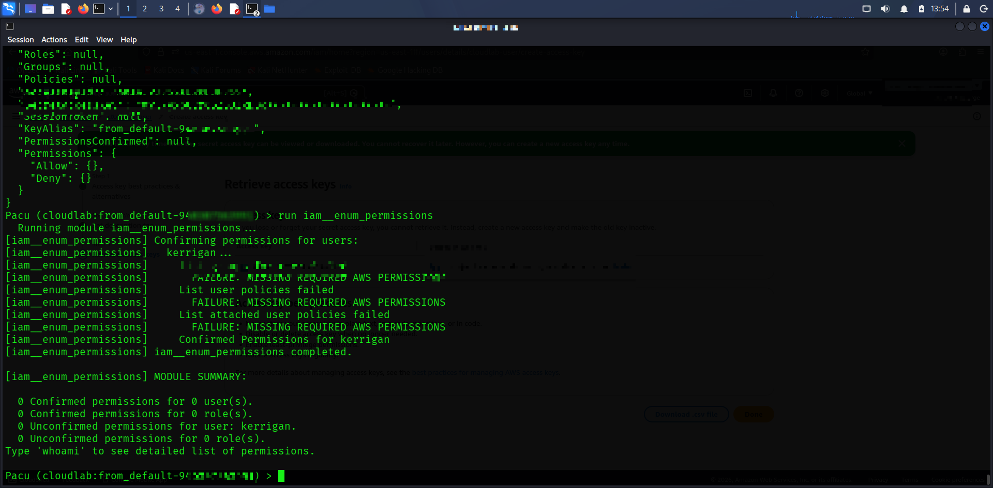

3: AWS IAM Dashboard Overview
The AWS IAM dashboard was reviewed to identify configured IAM users, roles, and security policies associated with the environment.
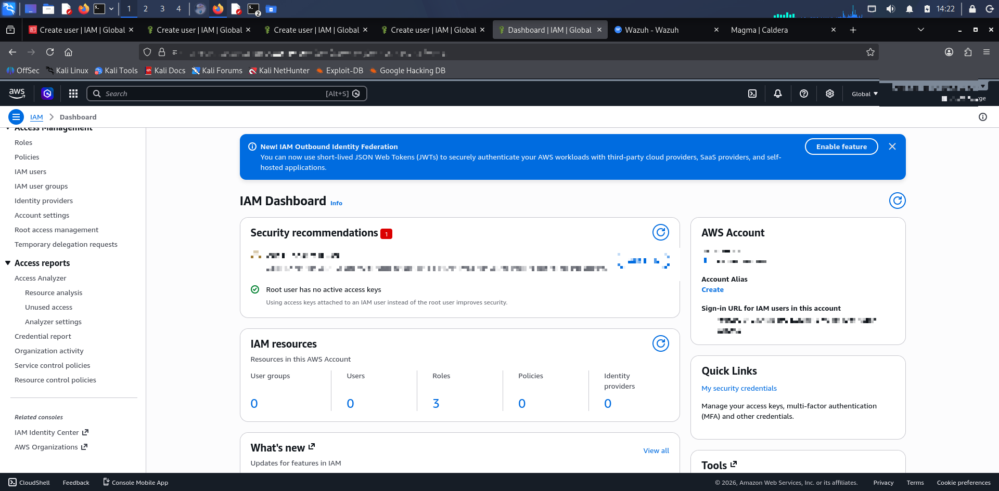

4: Creating IAM User for Cloud Attack Lab
A dedicated IAM user was configured for the cloud attack lab environment to simulate an attacker-controlled identity.

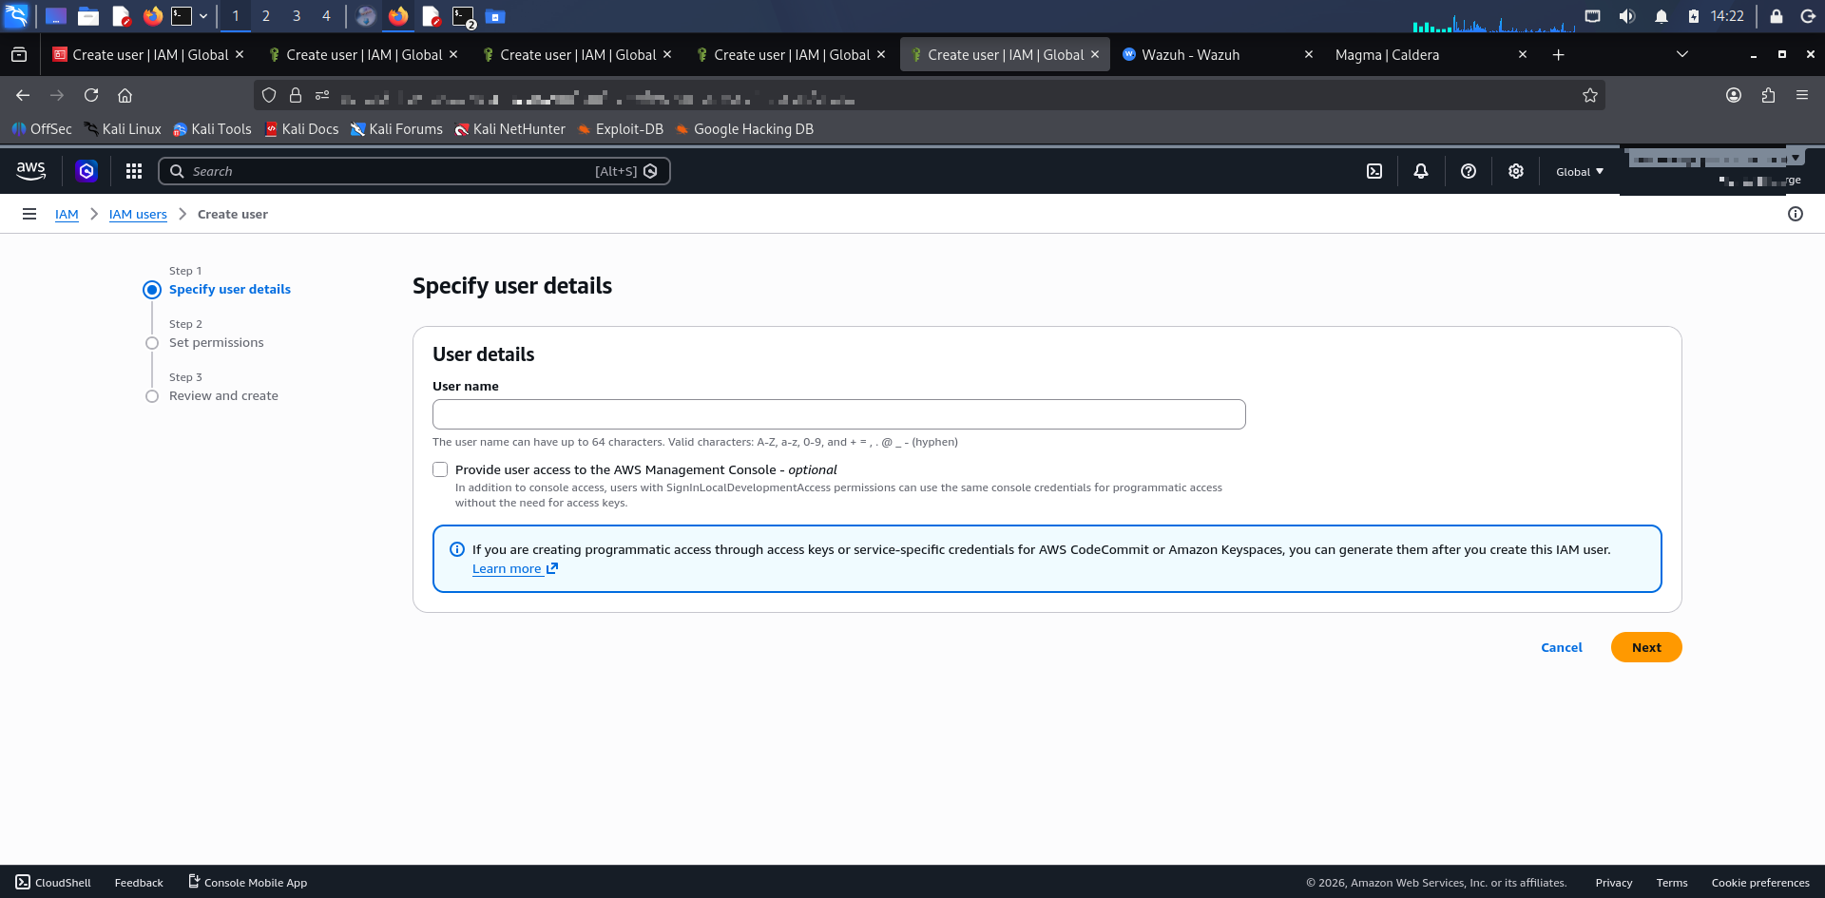

5: AdministratorAccess Policy Assignment
Administrative permissions were configured for the management account used to deploy and manage the CloudGoat scenario.

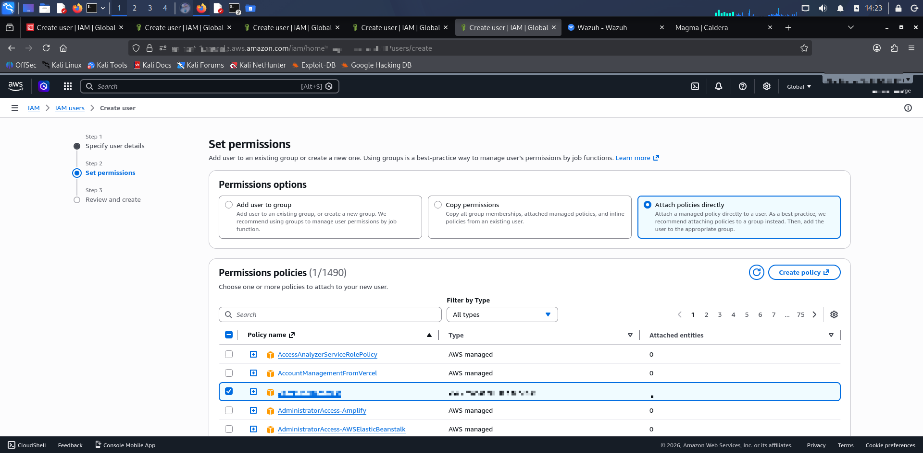

6: Enumerating IAM Roles Using AWS CLI
IAM roles were enumerated using AWS CLI to identify potentially vulnerable roles and instance profiles.
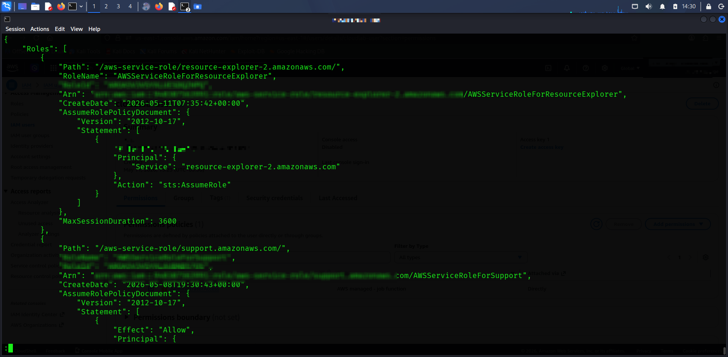

7: Reconnaissance and Permission Validation Attempts
Reconnaissance activities included testing AWS permissions, validating EC2 capabilities, and identifying escalation paths.
[Insert Screenshot Here: Reconnaissance and Permission Validation Attempts]
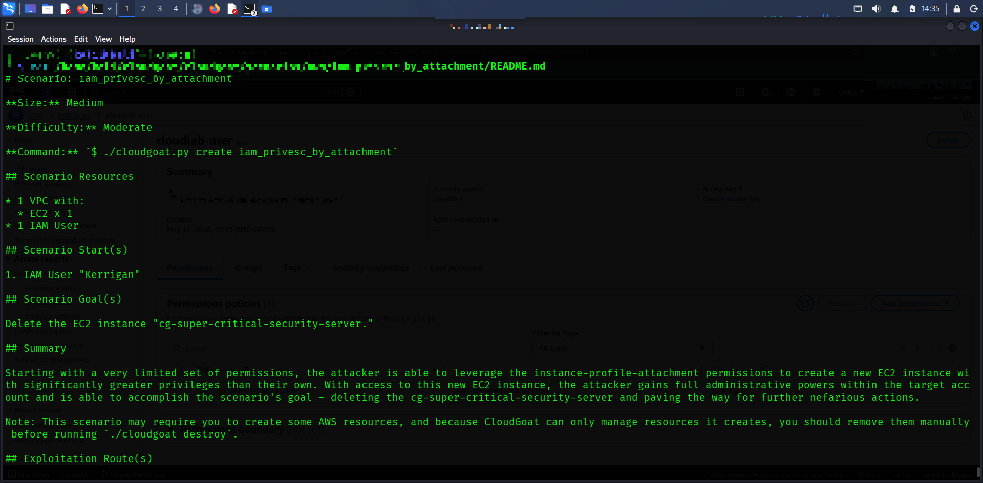

8: Analysis of Restricted IAM Meek Role Configuration
The restricted 'meek' role was analyzed and confirmed to contain deny-all permissions, limiting its operational capabilities.

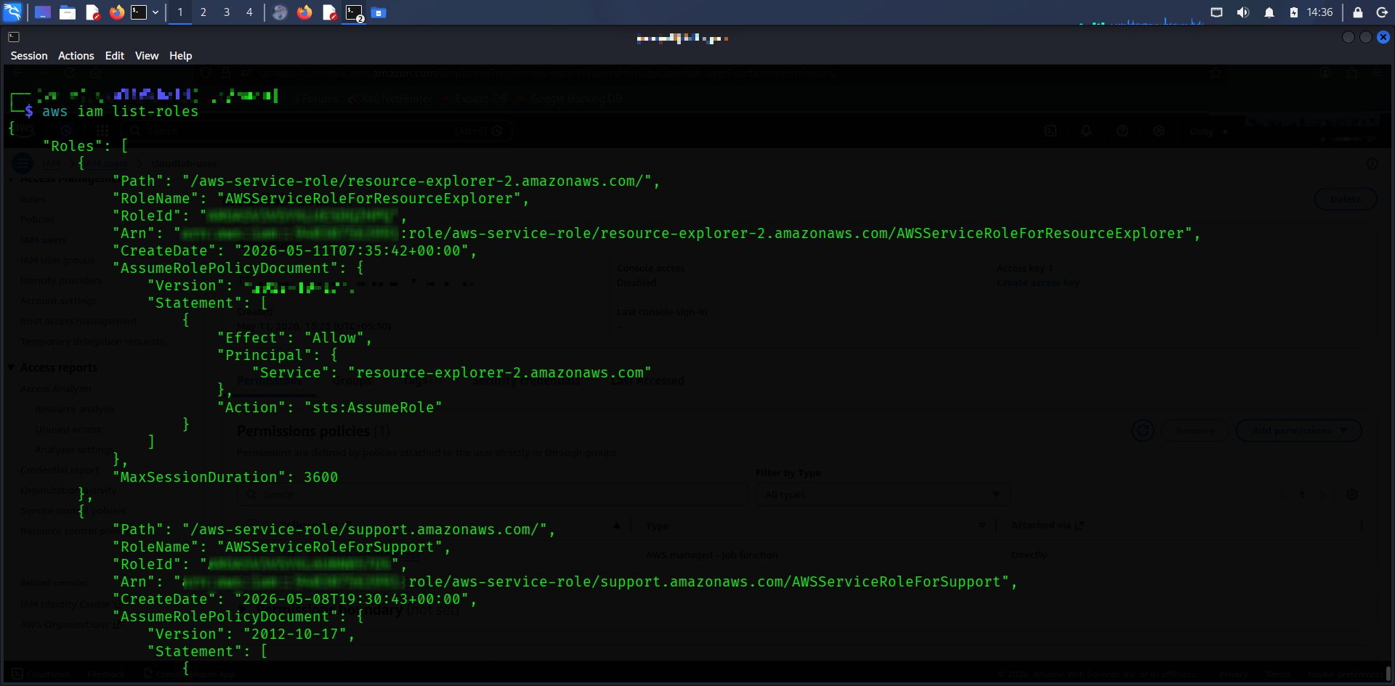

9: Discovery of Privileged IAM Role ARN
Enumeration identified the privileged 'mighty' IAM role, which contained wildcard administrative permissions.
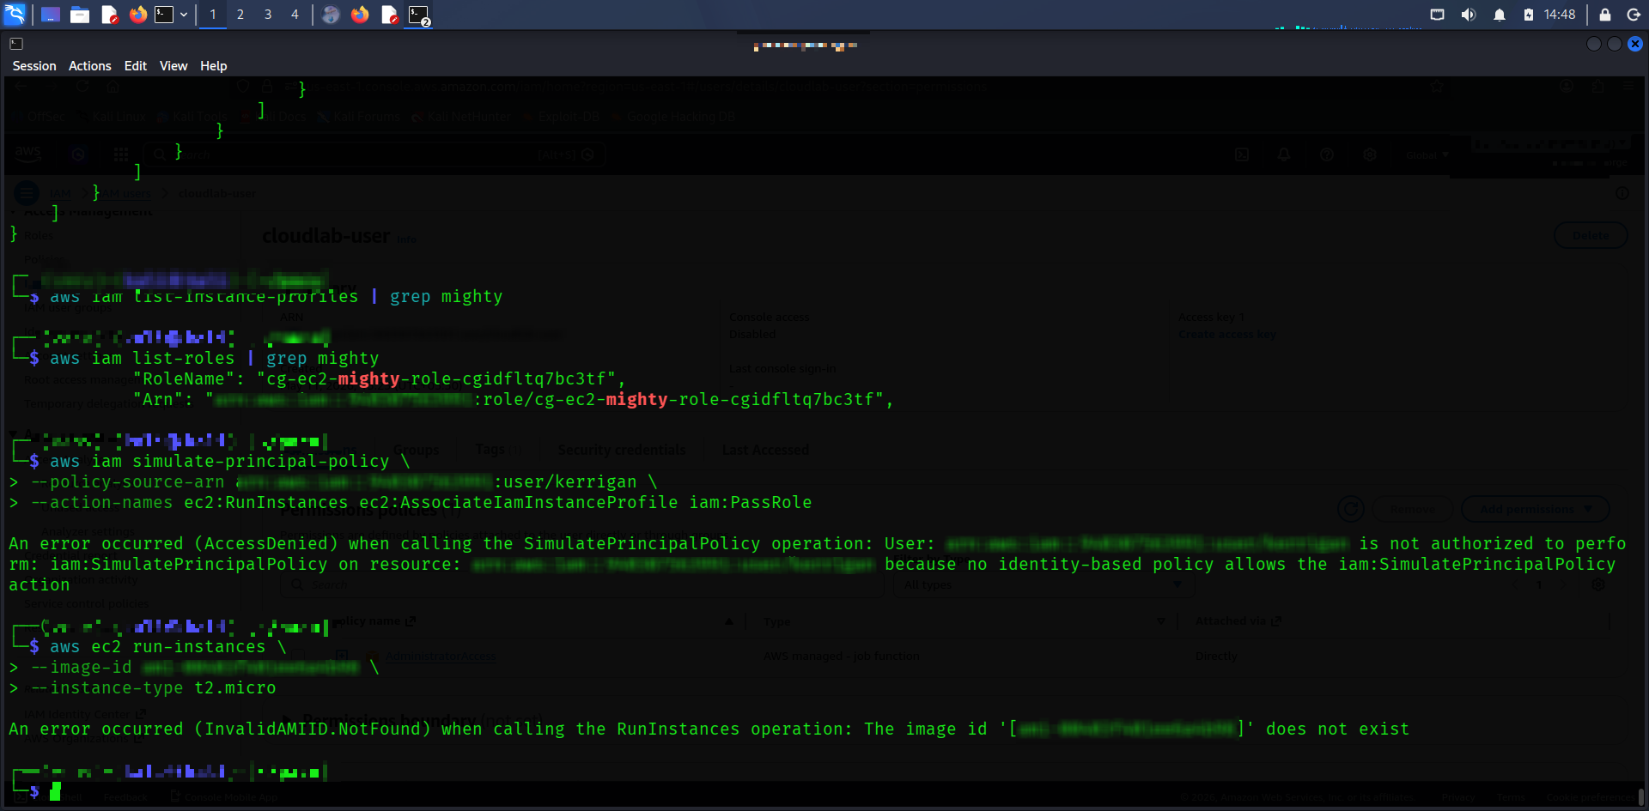

10: Analysis of Over-Permissive IAM Mighty Role Configuration
Terraform configuration analysis confirmed that the mighty role possessed unrestricted wildcard permissions (Action='*', Resource='*'). This represented the primary privilege escalation target.

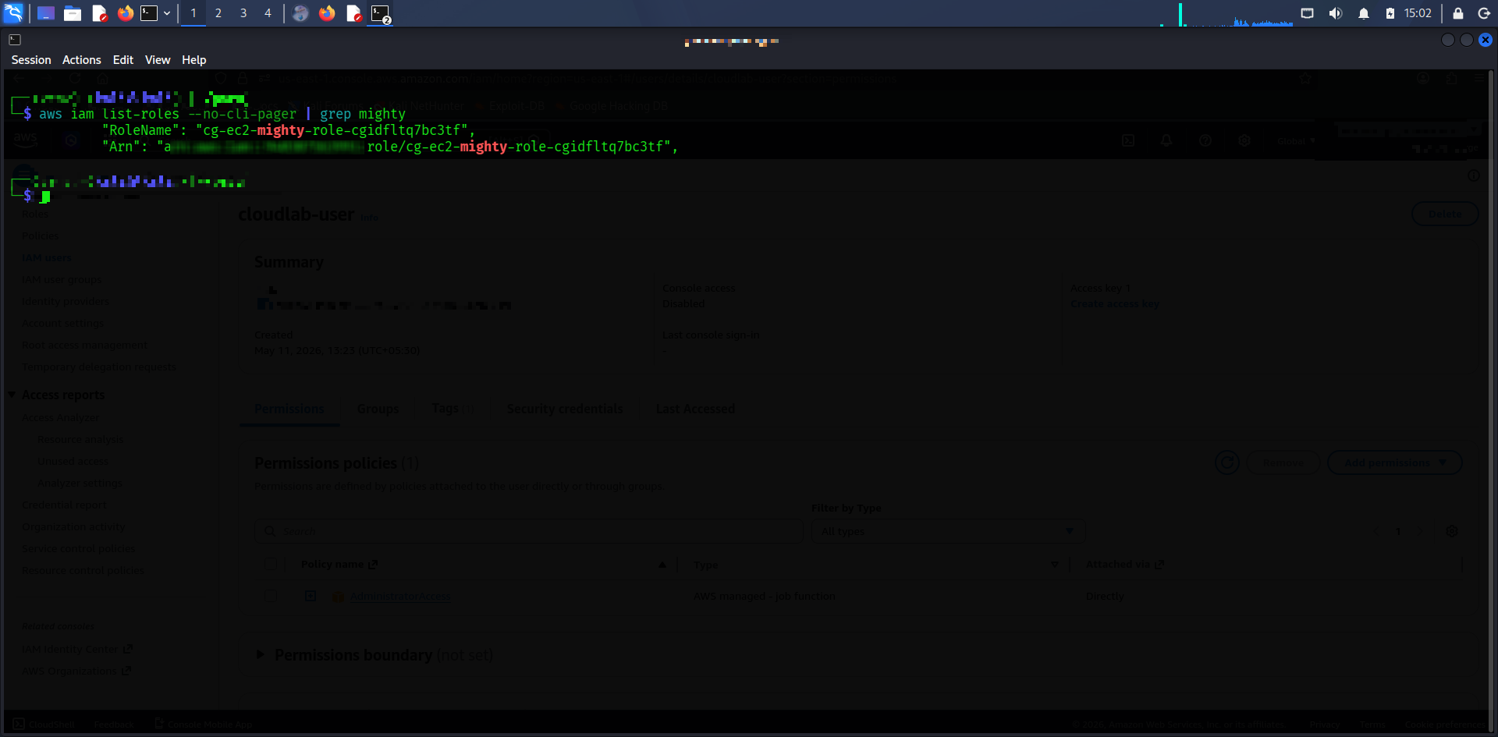

11: Review of Kerrigan User IAM Permissions
The Kerrigan IAM policy was reviewed and found to contain dangerous permissions including iam:PassRole and ec2:RunInstances.
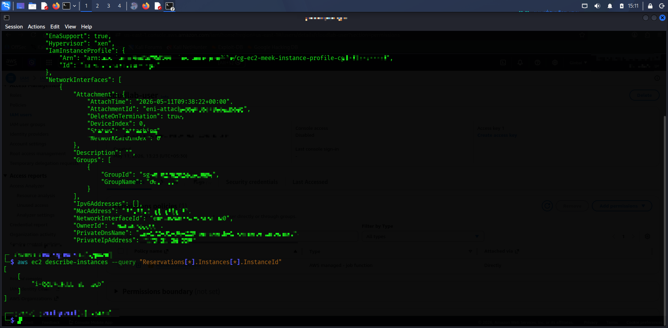

12: Launching EC2 Instance with Attached IAM Profile
An EC2 instance was successfully launched with an IAM instance profile attached, demonstrating abuse of EC2 launch permissions.
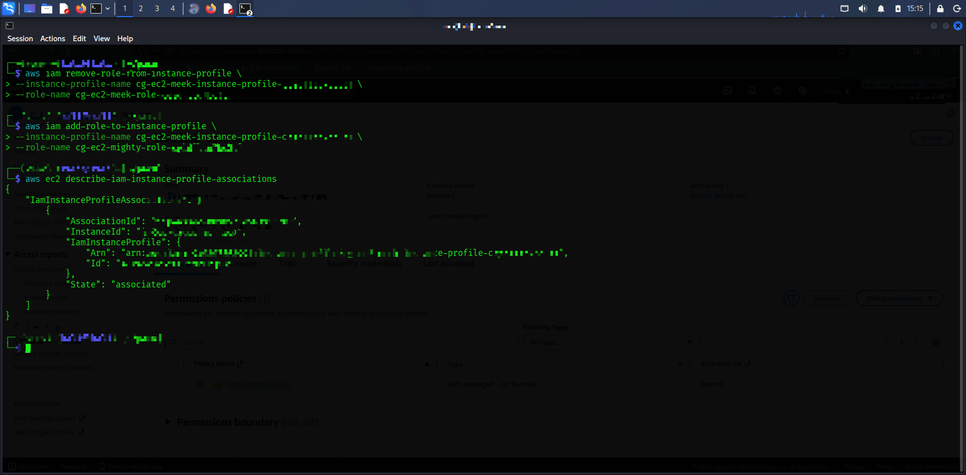

13: Enumerating EC2 Metadata and Attached IAM Profile
The EC2 instance configuration and associated IAM instance profile were enumerated to verify successful attachment.
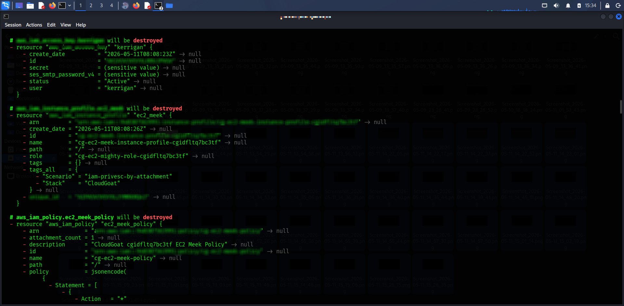

14: Extracting EC2 Instance Identifier
The EC2 instance identifier was extracted for subsequent instance-profile manipulation and validation.
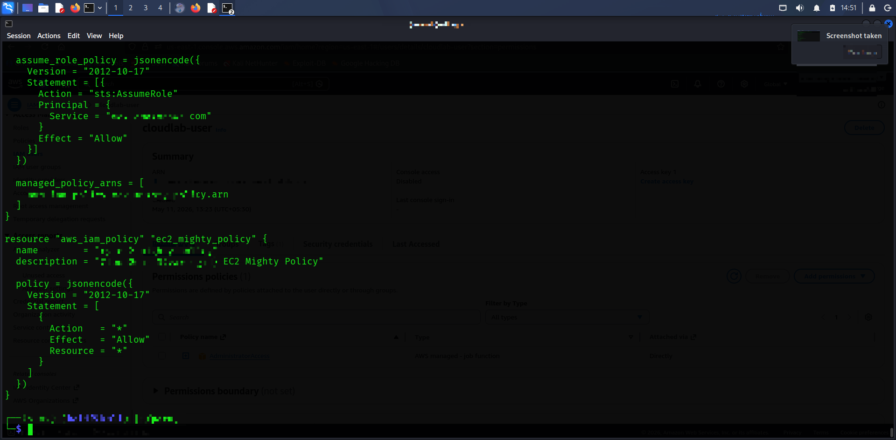

15: Failed Attempt to Add Privileged Role to Instance Profile
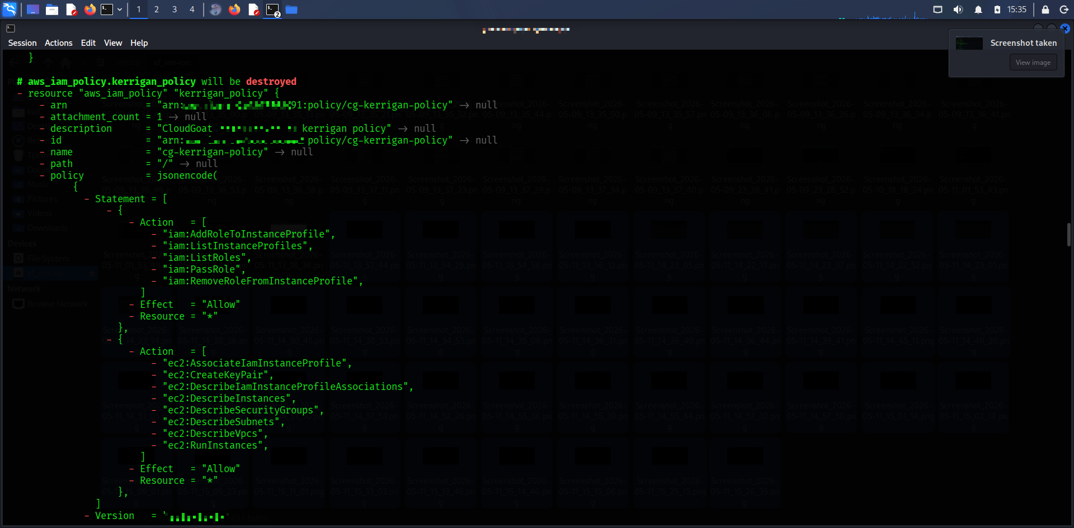
An attempt was made to add the privileged role to the existing instance profile. AWS quota restrictions prevented multiple role attachments, confirming the attack path logic.

16: Verification of IAM Instance Profile Association State
AWS instance-profile associations were verified to confirm successful attachment state and privilege escalation workflow.
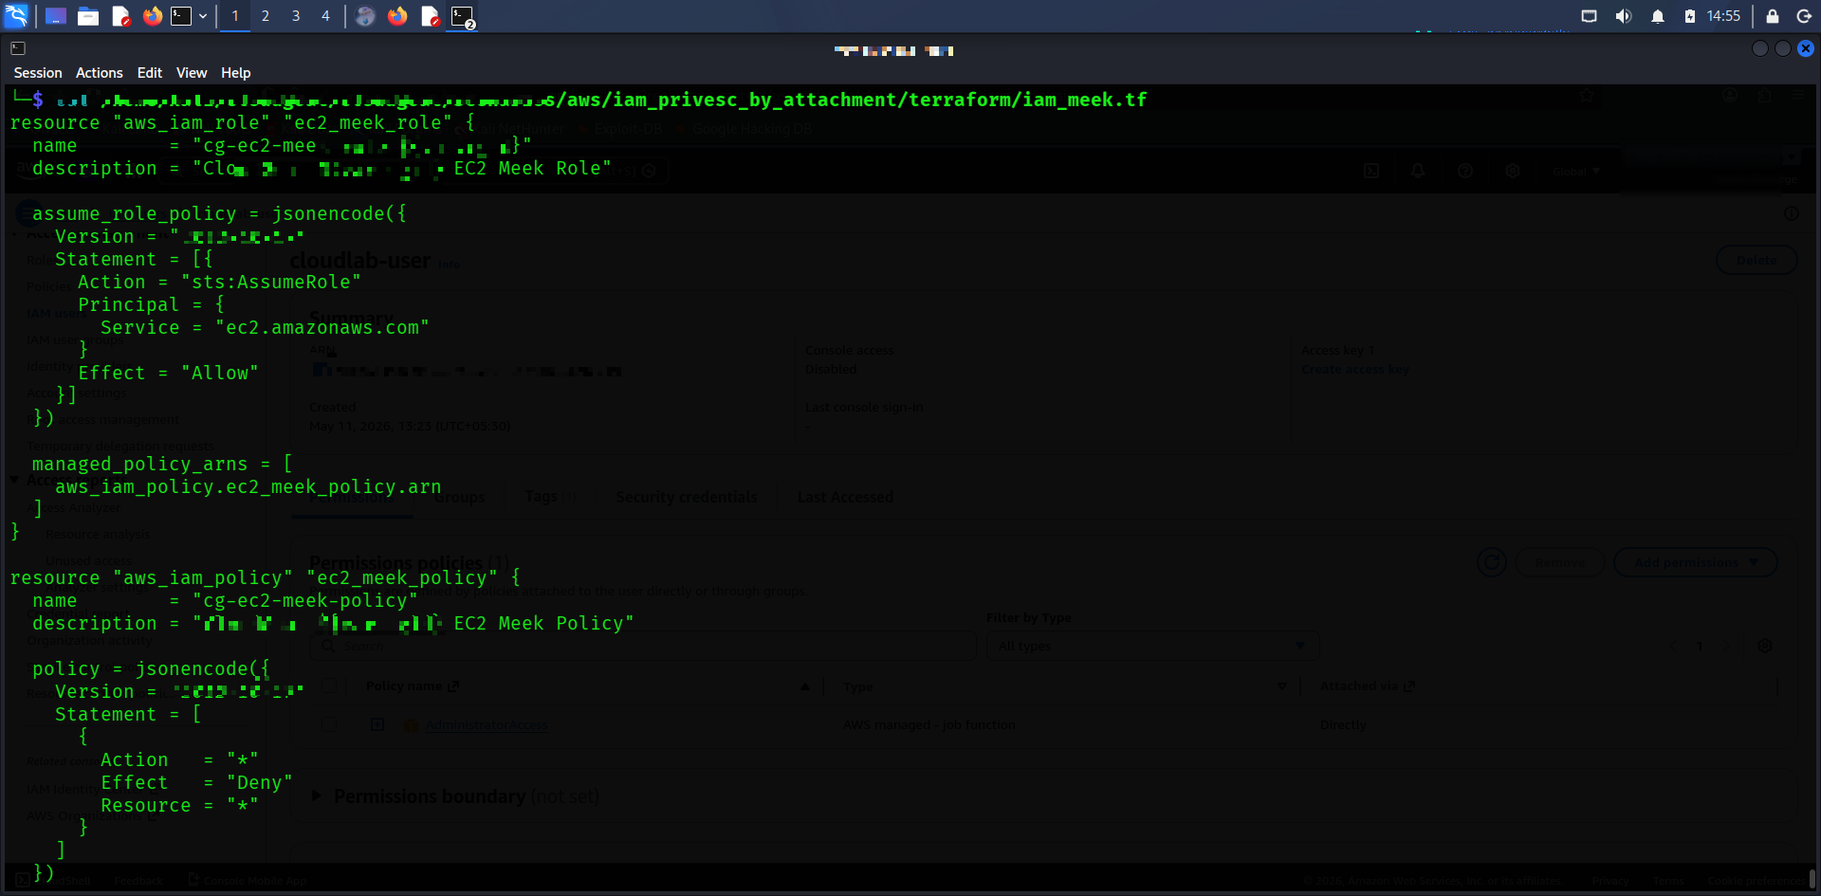

17: Destruction of Kerrigan IAM Policy and Permissions
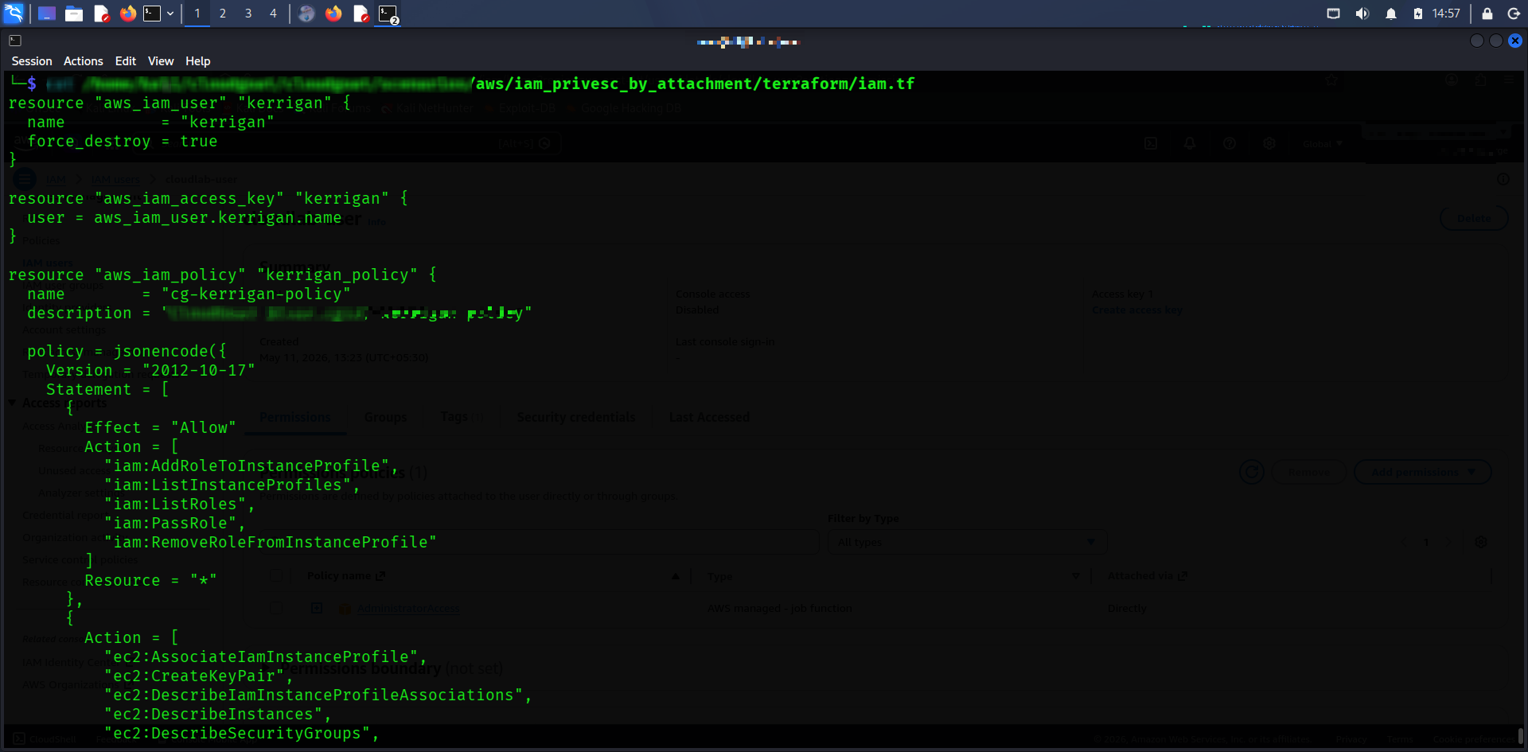
CloudGoat cleanup procedures removed IAM policies, roles, and permissions associated with the attack scenario.

18: Final Cleanup and Terraform Destroy Confirmation
Terraform destroy operations successfully removed all deployed AWS resources, preventing unintended cloud charges.
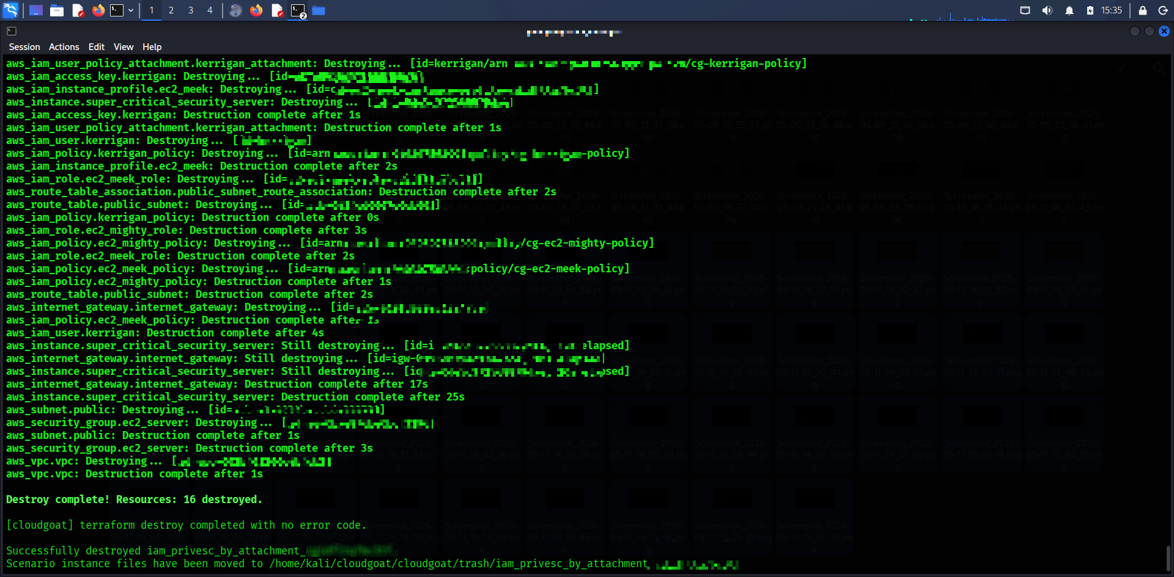

4. Findings
The Kerrigan IAM user possessed dangerous EC2 and IAM permissions.
Wildcard administrative permissions were assigned to the mighty role.
EC2 instance-profile attachment permissions can be abused for privilege escalation.
Infrastructure-as-Code analysis revealed insecure IAM policy configurations.
Cloud privilege escalation paths can be identified through Terraform analysis and AWS CLI enumeration.

5. Conclusion

The CloudGoat IAM privilege escalation scenario successfully demonstrated how insecure IAM permissions and EC2 instance-profile associations can be abused by attackers to escalate privileges in AWS environments. The assessment highlighted the importance of least privilege, strict IAM policy review, and continuous cloud security monitoring.

